Inland Empire Gymnastics Academy
COVID-19 HEALTH & SAFETY PROTOCOL UPDATES
May 4, 2022

IEGA is moving toward optional masking beginning May 16, 2022 and our timeline for a Return to a NEW Normal at IEGA has been updated and can be seen on the reverse side. Please note that we will continue to monitor COVID-19 numbers, particularly those in San Bernardino County, and it is possible that we may return to mandatory masking should numbers spike again. Please do not throw away your face masks. It is possible that we will go through "seasons" of masking in the months ahead, until more people in our community are fully vaccinated.
_________________________________________________________

Beginning May 16, facemasks will be optional FOR STUDENTS at IEGA when they are out on the gym floor. Students will still need to wear their face masks while in the waiting room, however, once in the gym, where the ceilings are extremely high and there is plenty of air movement, face masks can be removed and placed in their backpacks. We do STRONGLY encourage students to continue wearing masks in class, particularly those who have not been vaccinated against COVID-19. Please know that our staff will ensure that students who elect to continue masking are supported positively in their choice. Safety is always our main priority.

ALL ADULTS, whether vaccinated or unvaccinated, will continue to be required to wear masks while in the office area and waiting room. These areas are confined and do not have adequate ventilation or air movement. Parents participating in Play Gym or Tyke Gym will also need to wears masks while on the gym floor. Please note: It is more critical than ever that if anyone in your household is showing any COVID-19 or flu-like symptoms, consider getting tested and please keep your student at home until you receive a negative result. Makeup classes are available to accommodate missed classes.

ALL IEGA STAFF, whether vaccinated or unvaccinated, will continue to be required to wear masks at all times.
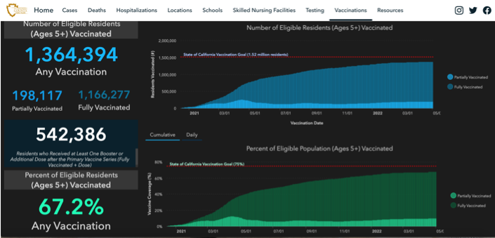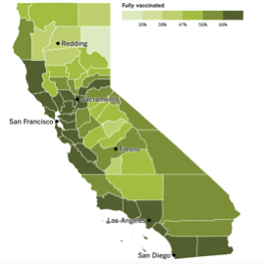
Current Vaccination Rates in San Bernardino County
Current Vaccination Rates in California

UPDATED Timeline for a Return to a NEW Normal at IEGA

Phase 1 - March 1, 2022

- IEGA will continue curbside check in for our students, however we will eliminate temp checks and health & wellness questions, relying on our families to do those things prior to arriving for class.
- Face masks will continue to be required for all students, staff and parents entering the building.

Phase 2 – May 16, 2022

- Masks for students will be optional, but highly recommended, unless directed otherwise by the California Department of Public Health and/or the CDC.
- Face masks will continue to be required for all staff and parents entering the building.
- Inside viewing will remain limited to one adult only for children enrolled in our preschool/kinder classes

Phase 3 – June 6, 2022 (subject to change)

- Masks for students will be optional, but recommended, unless directed otherwise by the California Department of Public Health and/or the CDC.
- Face masks for fully vaccinated staff will be optional on the gym floor, but recommended. All unvaccinated staff must continue to mask.
- Face masks will continue to be required for any parents entering the building.
- Inside viewing numbers will be increased – One adult for those children enrolled in Power Kids and in our preschool/kinder classes.

Phase 4 - Date Still To Be Determined

- Masks for students will be optional, but recommended, unless directed otherwise by the California Department of Public Health and/or the CDC.
- Face masks for fully vaccinated staff will be optional on the gym floor, but recommended. All unvaccinated staff must continue to mask.
- Face masks will continue to be required for any parents entering the building.
- Inside viewing will remain be increased again. Classes still to be determined based on level and time of day

Phase 5 – Date To Be Determined

- Masks for all students and all staff will be optional, but recommended, unless directed otherwise by the California Department of Public Health and/or the CDC.
- Face masks will continue to be required for any visitors entering the building.
- Inside viewing numbers will be increased. Classes still to be determined based on level and time of day

